Porsche (China) Motors Ltd.
Parts supply Chain Solution
South of China


15/F, Tower 3, Lujiazui Financial Plaza, No. 826 Century Avenue, Pudong, Shanghai

1. Preface 4

2. General Tender Information 5
2.1. Schedule for the Tender 5
2.2. Contact Persons and Address for the offer 5
2.3. Reservation 5

3. Competency Profile 7
3.1. Project Scope 7
3.2. General Requirements 7
3.3. Qualification certification 8
3.4. Dealer Development overview 9

4. Inbound Transportation 11
4.1. Transportation Services Requirements 11
4.1.1. Transport Volume Development 11
4.1.2. Tracking Consignments 11
4.1.3. Contact Information 12
4.1.4. Reporting 12
4.1.5. Hazardous Goods and Substances Harmful to the Environment 12
4.1.6. Requirements Pertaining to Package Handling 12
4.1.7. Agreement on Claims for Damages 12
4.1.8. Emergency Concept 13
4.1.9. Environment & Sustainability 13
4.2. Inbound Key Performance Indicators (KPI) 14

5. Parts Warehousing (PDC) 16
5.1. General Requirements 16
5.2. DG warehouse requirements 16
5.2.1. Hazardous Chemical 16
5.2.2. Storage of Li-Ion Batteries 16
5.3. Special Warehouse Requirements 19
5.3.1. Label requirement 19
5.3.2. Automation & Digitalization Solution 20
5.4. General Warehouse Processes 20
5.4.1. Inbound 20
5.4.2. Storage 21
5.4.3. Porsche Best Practice for Warehouse Equipment 21
5.4.4. Outbound 25
5.5. Special Processes 26
5.5.1. Scrapping Parts 26
5.5.2. Stock-Taking / Inventory Count 27
5.5.3. Shelf life parts management 27
5.5.4. Packaging Optimization 27
5.5.5. Hazardous chemicals and dangerous goods 27
5.5.6. Local parts management 28
5.6. Operational System and Communication 28
5.7. Warehouse Key Performance Indicators 28
5.8. Human resource requirements 28
5.8.1. Organization 28
5.8.2. Recruitment 29
5.8.3. Qualification & Authorization 29
5.9. Miscellaneous 29
5.9.1. Warehouse Operating Hours 29
5.9.2. Emergency Concept 29
5.9.3. Reports 30
5.9.4. Environment and Sustainability 30

6. Contractual Conditions 32
6.1. Contract Duration and Terms 32
6.2. Insurance 32
6.3. Liability 33
6.4. Use of Subcontractors 34
6.5. Responsibility/Warranty 34
6.6. Continuous Improvement Process 34
6.7. Legislation/Guidelines 34
6.8. Governing Law, Jurisdiction and Place of Fulfilment 35
6.9. Invoicing 35
6.9.1. General Terms 35

7. Content of the offer 36

8. Appendixes Listing 37

Preface
PCN is a subsidiary of Dr. Ing. h.c. F. Porsche AG and has commenced operations since 2001 in China. Presently with 125 Porsche centres in China, PCN provides a comprehensive network of sales and service of imported Porsche vehicles, spare parts and accessories to its partners. Currently all dealers are supplied by three PCN warehouses in Shanghai, Dongguan and Tianjin.
Shanghai Lingang warehouse has been successfully operating since it’s Go Live in 2016, we have efficient and seamless cooperation with our existing service provider. As current contractual period is approaching expired, we decide to start biding project to gain possibility of cooperating with more potential service providers, this documentation provides a general description of the physical and informational procedures, the specific tasks to be performed by the logistics service provider, as well as information on technical and organizational conditions.
Within the scope of the supply chain, the entire logistics process (Inbound Transport and Warehousing) in central of China has to be handled by qualified logistics service providers. The tender for Outbound transportation has been provided in another procurement project.
Porsche (China) Motors Ltd. (PCN) is keen to have a minimum number of service providers for all functions, up to and including a single source solution, but reserves itself to divide the tender in several parts during the quotation procedure and conclude for each part a specific contract.

General Tender Information
For all parts, Porsche (China) Motors Ltd. asks for fixed conditions during the first contract period.
For normal warehouse, the contract period is 3+2 years.
For DG warehouse, the contract period is 3+2 years, and Porsche (China) Motors Ltd reserves the right to adjust contract period according to supply chain strategy change.
Nevertheless, the service provider and Porsche (China) Motors Ltd. may request a review of the prices in accordance with the status of service provider’s continuous improvement and the future economic conditions, and the prices may be changed by mutual agreement in writing. The calculation basis of the quoted prices shall be mentioned in detail.

Schedule for the Tender
Proposals must be received by Porsche (China) Motors Ltd. via email no later than the 13th of Feb 2026 by 12:00 pm (noon) EST time. Failure to submit proposal by deadlines WILL disqualify Supplier from further participation.
Listed below is a summary of the dates specified above on which actions are to be taken or completed.

Beginning of the tender phase | Submission time for the offers | Provider presentation | Provider decision
Jan 15th, 2026 | Feb 13th, 2026 | Mar 3rd, 2026 | By May.2026
Note: Dates are subject to change by Porsche (China) Motors Ltd. Any change to the above schedule will be communicated to all RFI participants.

Contact Persons and Address for the offer
Porsche (China) Motors Ltd.  13/F Tower3 Lujiazui Financial Plaza No 826 Century Avenue Pudong Shanghai | Shoupeng Li (PCN)  Assistant Manager After Sales Warehouse Operations  Tel.: +86 18516112415  Shoupeng.li@porsche.cn  Amy Wang (PCN)  Commodity Manager  Tel: +86 21 6156 5483  Amy.wang2@porsche.cn

Reservation
Porsche (China) Motors Ltd. reserves the right to:
- Adjust any Supplier’s proposed costs based on a determination that selecting a particular Supplier will involve incurring additional or hidden costs.
- Waive or change any formalities, irregularities or inconsistencies in proposal format or delivery.
- Consider a late modification of a proposal if the proposal itself was submitted on time and if the modification makes the terms of the proposal more favorable to Porsche (China) Motors Ltd.
- Negotiate any aspect of a proposal with any Supplier and negotiate with more than one Supplier at a time.
- Accept any submitted counterproposal or addendum whether there are contract negotiations with other suppliers already in progress.
- Extend the time for submission of all proposals
- Postpone the decision-making date.
- Not disclose to any Supplier the results of the evaluation process or the reason why a Supplier was or was not successful.
- Select the next most responsive Supplier if negotiations with the Supplier of choice fail to result in an agreement within a specified time frame.
- Postpone the project based on business requirements.
- The tender could result in several contracts.

Competency Profile

Project Scope
Porsche (China) Motors Ltd. asks for a defined contact partner/project manager to realize the project within the following timeline from each vendor/supplier:

Go live Warehouse operation: Aug 1st 2026

General Requirements

- Inbound Transportation: The logistic service provider shall provide transportation from the defined ports of entry (sea freight, airfreight) to the warehouse of Porsche (China) Motors Ltd.
- Warehouse Operation: Goods receipt, storage, picking and packing of goods as per order, as well as equipment, MHE, Racks, and maintenance or repair.
- Warehouse rental: the main warehouse rental is NOT in scope of this tender while Hazardous chemical warehouse rental is in scope of this tender.

Most of the processes are defined in the Porsche owned system, which is based on SAP/EWM. The proper handling of the system is a basic requirement for all service providers. The logistics process is outlined on the following page.
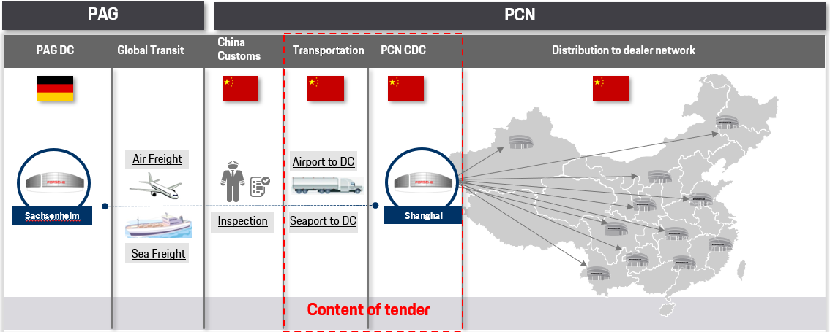

Remark: Porsche (China) Motors Ltd reserves the right to adjust goods flow according to supply chain strategy change.

Qualification certification
- Porsche (China) Motors Ltd. will subject the contractor to a regular quality audit (schedule to be determined). The certification ISO9001, ISO14001, TISAX certification or alternative ISO27001(latest version) or similar standards is required for all services provided by contractor (including subcontractors). Evidence of certification must be supplied.
- The contractor should be qualified for handling DG and comply with statutory requirements (including subcontractors).
- The contractor is preferred with 5 years or above experience of automotive parts storage and distribution.
- The contractor should comply with all of the other statutory requirements by local government which is not included in the tender document.

Dealer Development overview

Dealer Overview 2023 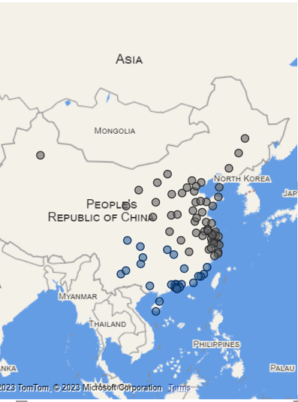  Dongguan  n  Shanghai | Dealer Overview 2025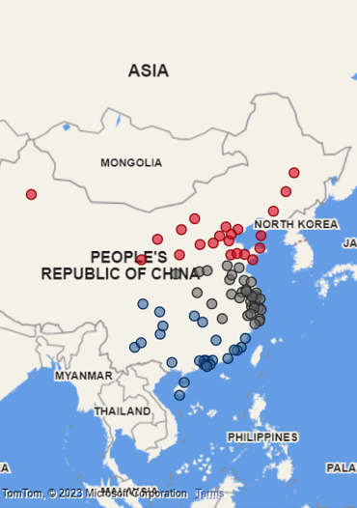  Shanghai  Dongguan  n  Tianjin
Note: The service provider shall refer to the Dealer list in Appendix 1: Dealer list

Inbound Transportation
From Port of Entry (Ocean /Air) to PDC



Inbound Transportation
The transportation between the global warehouse in Sachsenheim to the Airport – Sea Port of entry (warehouse dock) is managed by PAG (in accordance with actual terms of delivery, CPT). The inbound transportation from the ports (sea port and airport) has to be managed by a logistic service provider.
Porsche (China) Motors Ltd reserves the right to adjust goods flow according to supply chain strategy change.
Customs clearance is excluded in the content of inbound transportation scope.

Transportation Services Requirements
Contract party will be Porsche (China) Motors Ltd.
Module | Shipment Type | Origin  Suggested Port of Entry: | Destination | Collection interval | Lead time target
1a | Inbound Transportation from Airport to Warehouse | Shanghai Pudong International Airport, PVG | PDC Distribution Warehouse in Shanghai Lingang | Daily | 1 working days
1b | Inbound Transportation from Sea Port to Warehouse | Shanghai Yangshan port, CNYGS | PDC Distribution Warehouse in Shanghai Lingang | Daily | 3 working days

Lead time is calculated from release notification till goods arrival in PCN warehouse. Customs clearance time is also excluded in the lead time of inbound transportation.

Transport Volume Development
Detailed annual transportation volume information can be found in Appendix 2: Inbound volume.

Tracking Consignments
Tracking & Tracing (post-carriage from port to the warehouse) will use the forwarding agent’s Internet homepage or reports. Inquiry number setting by shipping document shall be used as the ID reference. The ability to feed information directly to Porsche (China) Motors Ltd. will be a requirement in the future. All associated expenses and costs to configure the supplier’s/vendors system(s) to meet the needs of Porsche (China) Motors Ltd. are the sole responsibility of the supplier/vendor.

Contact Information
A fixed contact person should be accessible daily from Monday through Saturday between 7:30 a.m. and 6:30 p.m. On occasions, and Sundays might be required. A 24-hour hotline for emergencies is required.

Reporting
Porsche (China) Motors Ltd. expects a Daily Tracking Report containing information about quantities, quality. And a Monthly Management Report (MR) including quantities, quality and cost must be completed in accordance with Porsche (China) Motors Ltd. specifications and sent to Porsche (China) Motors Ltd. by the 10th business day of the following month.

Hazardous Goods and Substances Harmful to the Environment
The Porsche assortment contains the following hazardous goods classes: 2.1, 2.2, 3, 4.1, 8 and 9. The inclusion of hazardous goods must be possible with every consignment and shall thus be subject to national laws, ordinances, and regulations on the conveyance of hazardous goods and environmentally harmful substances. The currently valid version of these rules and laws at the time concerned shall prevail in each case.
The same transport durations that apply to our normal freight shall apply; delays must be reported immediately with the target lead time 1 hour. In the case of accidents involving hazardous goods, an accident report must be prepared and sent to Porsche (China) Motors Ltd./contractor person responsible for hazardous goods with the target lead time 1 hour.
DG inbound transportation qualification requirement is included in Appendix 19_危险货物运输及危险化学品存储企业资质合规要求.

Requirements Pertaining to Package Handling
Basically, shipping goods are packed in cardboard boxes with the appropriate size by consignees or in sea freight containers.
As an exception the below packages are used for shipping goods.
- Porsche original cardboard boxes (e.g., body parts, windshield, etc.)
- Metal and wooden frames for specific vehicle components (e.g., engines, transmission, etc.)
- Wooden boxes (display rack, furniture equipment, etc.)
In view of the high value of the goods, the packages are to be treated with the utmost care during transportation, storage, and handling, so as to avoid any damage. The goods must be kept dry. Stock must be shipped in closed trucks only (dry vans).

Agreement on Claims for Damages
A specific process has to be implemented for dealing with claims between the contractor and Porsche (China) Motors Ltd. (agreement on claims for damages).
The contractor is to keep statistics of damage occurring in transit and report on the statistics via a Monthly Management Report (MR) to Porsche on the 10th business day of the following month.
Cases of damaged goods have to be reported after being ascertained. Subsequent notice of any concealed damage which has been caused by the contractor may be given within the statutory time limits.

Emergency Concept
An elaborated emergency concept (service recovery procedures) has to be prepared for the scope of transportation services (e.g. technical defect of a truck (breakdown), strikes, etc. …) and presented in the offer.

Environment & Sustainability
Porsche (China) Motors Ltd. is committed for protecting the environment. The contractor should strive to meet environmental standards such as ISO14001, or comparable management systems. Porsche reserves the right to implement annual audits concerning the protection of the environment.
In performing its services under this agreement, the contractor takes appropriate actions to conserve resources and to avoid environmental impacts in all modes of transportation.
Only means of transportation which correspond to the state of the art, with reduced fuel consumption and noise emissions, are to be used. Refer to Chinese laws and regulations.
In order to reach sustainability target of Zero Emission Target 2030, Porsche (China) Motors Ltd. is requesting a sustainable solution as green inbound transportation CO₂ proposal to replace traditional diesel trucks to reduce
CO₂ emission in daily inbound transportation delivery.
The contractor should propose a green inbound transportation proposal with significant CO₂ release reduction and minimum cost increasing impact. The proposal should work on the most suitable green truck types and the replacement % of traditional diesel trucks to have minimum negative transportation cost impact.
Green energy is listed for reference only. The green inbound transportation proposal is not limited to the list below.
Alternatives to diesel | Percentage reduction of GHG
Electric & Hydrogen | 100%
BTL & B | ~ 60%
LNG & CNG | ~ 34% (+- 5-10%)
BWO | ~ 20-40%
Other: RD & HYB | n/a
BTL: Biomass to liquid; B: Biodiesel; LNG: Liquefied Natural Gas; CNG: Compressed Natural Gas;
BWO: Biodiesel (waste oil); RD: Renewable Diesel; HYB: Diesel (Hybrid)

Referring to GHG (GREENHOUSE GAS PROTOCOL), carbon emission = total distance travelled of each type of vehicle * emission factor of each vehicle type. Consulting with PCN Corporate Strategy and Development Team, 0.546 kg CO₂ e/km can be applied for traditional diesel trucks CO₂ emission calculation. The contractor should remark if different calculation methodology is applied for CO₂ emission calculation.

The green inbound transportation proposal is supposed to include:
- Green inbound truck type, green inbound transportation cost (Appendix 9), replacement % of traditional truck delivery
- Green inbound transportation CO₂ emission calculation and CO₂ emission reduction calculation compared to traditional diesel trucks.

Inbound Key Performance Indicators (KPI)
The service provider must undergo a regular quality audit. The service provider (including subcontractors) certification ISO9001 (latest version) or similar standards for all services provided is preferred. Evidence of certification must be supplied.
TRANSPORT QUALITY TARGETS (Monthly base)
TYPE OF FAULT | TARGET*
Delays  (Number of delayed deliveries/numbers of all deliveries per month) | 99%  On time delivery
Damages  (Items damaged/number of items delivered deliveries per month) | 100%  Parts in good condition
Loss  (Items lost/number of items delivered deliveries per month) | 100%  No loss
*If the failure rate exceeds the target mentioned above and if it may be influenced by the service provider’s processes (excluding quality defects, for example), Porsche (China) Motors Ltd. reserves the right to deduct a percentage of the costs charged or the value of items damaged/lost from the total invoice amount. (Percentage will be determined based on vendor past performance and incident in question)
Each fault has to be explained by the logistics service provider. The service provider is to be responsible for completeness, safety and timely delivery of goods shipped.
The service provider is entitled and required to choose a reliable insurance company and to insure the cargo against theft, damages and accidents in order to cover any losses caused by logistics faults. Porsche (China) Motors Ltd. must be listed as “additionally insured” under the carrier’s policy and evidence of such must be provided to Porsche (China) Motors Ltd. within the first thirty (30) days of the agreement being accepted.

Warehouse Operations (PDC)
Inbound and Outbound Shipment Requirements



Parts Warehousing (PDC)

General Requirements
The current warehouse operation planning is based on the existing warehouse location. However, Porsche (China) Motors Ltd reserves the right to migrate to a new location when necessary and the logistics service provider shall design the optimal layout for the new warehouse to ensure highest efficiency. Appendix 23_Warehouse layout is based on current warehouse situation.

DG warehouse requirements

Hazardous Chemical
A separate hazardous chemical warehouse nearby (less than 1h transport time to normal warehouse) for storing hazardous goods according to the local law is necessary.
Warehouse Class should be defined based on DG classes by local Law.
The warehouse space is required to be no less than 800 sqm (400sqm to store DG and chemical parts, and 400sqm to store Li-Ion batteries-please according to relevant HV Battery information to define storage class), probably max. 2,000sqm for future extension. Warehouse rack has to be installed in order to utilize the warehouse space for DG and Chemical Parts.
However, the goods could be stored in different categorized warehouse based on the goods SDS classification, e.g. stored in different buildings. But goods storage in same compound/yard is recommended.
And for the batteries, supplier are allowed to store them in a non-DG warehouse as long as it meets the local legal requirements
Estimated space requirement:
Calculated space  [in m²] | FY2026(H4) | FY2027 | FY2028(H1)
Searching Parameter | 800 sqm | 800 sqm | 1,000 sqm
The space is calculated based on same storage conditions in main warehouse.
PCN reserves the right to adapt the space requirements based on actual situation and inventory volume
This area must be equipped with appropriate fire security facilities and Personal Protective Equipment (PPE). Moreover, it must be prevented that any material can drain away in the immediate ground and into any sewers (Storm or Human Waste). All dangerous goods handling requirements are the sole responsibility of the PDC warehouse vendor.
The DG classes currently used are: 2.1, 2.2, 3, 4.1, 8 and 9. Other classes may follow in the future. details referring to Appendix 14_DG list.

Li-Ion batteries specific storage requirements:
- To comply with the Chinese national law in general

- Check national laws for prevention of water pollution

- Fire detection with a connection directly to the fire department

- Fire extinguishing inside buildings and hand fire extinguishing for containers

- Sprinkler system for shelves storage

- A storage area with temperature control between 5°C - 30°C in warehouse to store HV/Li-Ion batteries. Humidity controlled area (<60%)

- Standard HV/Li-Ion battery storage that complies with Chinese national law in general

- The storage area must be equipped with fire-fighting equipment as per local regulations. A facility and layout design is necessary.

- Comply to national laws for prevention of water pollution

- Batteries must be stored separately from other warehouse material with a distance of at least 2.5 meters in a designated area, clearly marked by a sign following local regulations.

- Batteries have to be protected against mechanical damages and stored out of traffic ways to prevent vehicle collision.

- All gates and transport routes must be wide and high enough to allow safe battery handling

- No direct sunlight on storage area

- Facility must contain a quarantine area for batteries with status “warning” and “critical”, which is recommended to be outside, with at least 5m distance to the next building.

Status of a battery:

 |  | Storage inside the building | Storage outside the building
New and used batteries* (still functional) | Non-critical | Standard storage | Not applicable
New and used batteries* (no longer functional/damaged) | Critical |  | - Container with a distance of more than 10m to the building or as per local requirements,  - Otherwise storage inside a F-90 container is necessary
*Weights between 150 - 1100kg with package, sizes up to 2.50m*1.65m*1.30m (Appendix 15 HV Battery Information)

- Still functional: New and/or used ones, which are not damaged by visual, functional and thermic criteria.
- No longer functional: Damaged batteries which are dangerous, like damaged housing or cells, no more using is allowed

Storage Conditions for Li. Ion batteries: Country specific regulations will supersede the following regulations. Deviations have to be documented towards Porsche China
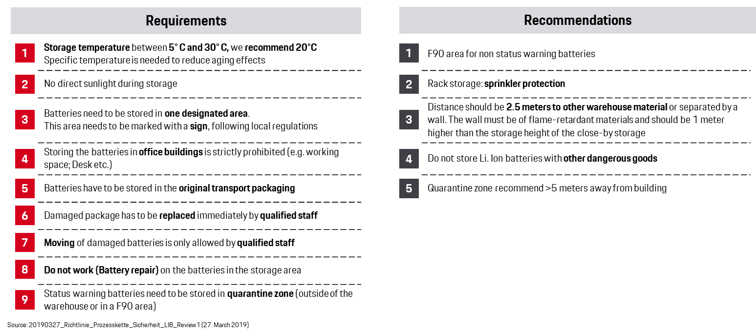
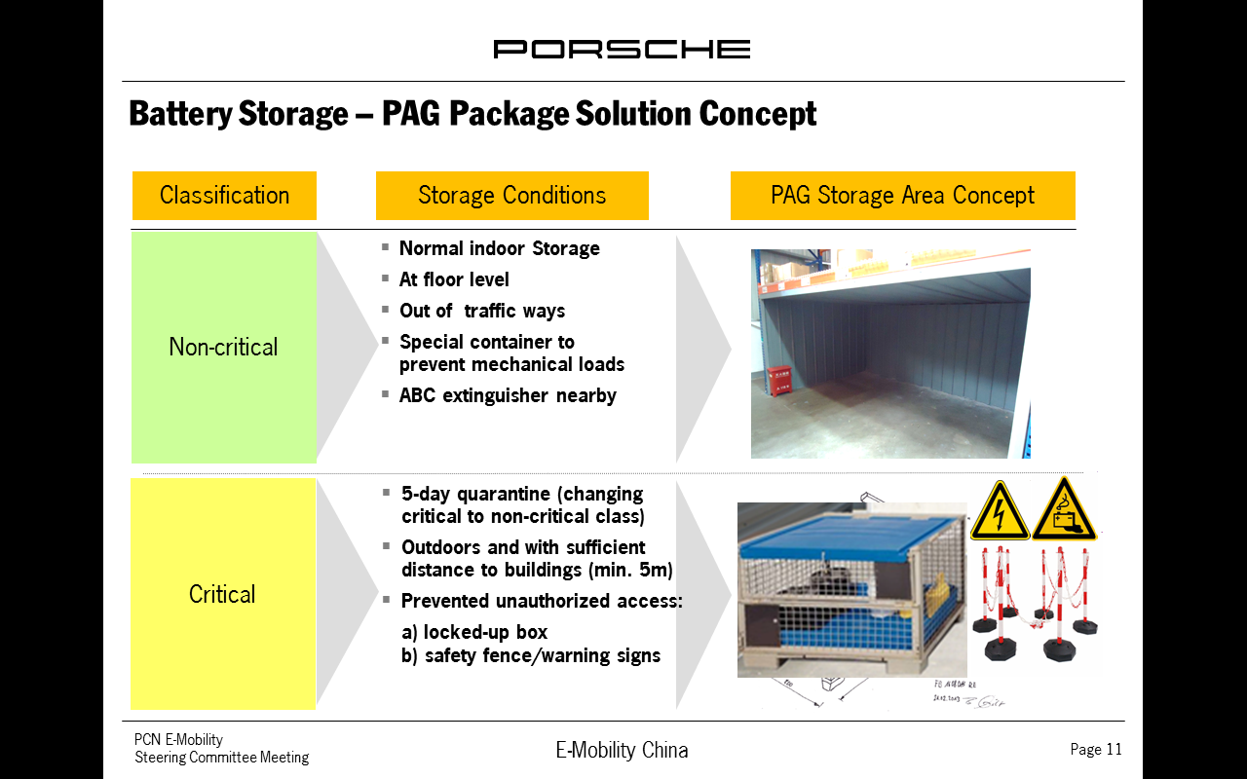
Technical and Organizational Requirements

- Access control for unauthorized persons
- Operation of the storage area has to follow processes defined by PCN
- Equipment and qualified personnel to handle large Li-Ion batteries are needed. Fork lift with at least 2m fork length is necessary. Handling includes unloading and loading transport trucks, moving batteries into and inside the storage area.
- Prepare training or a guide for staff members on the dangers when handling Li-Ion Batteries.
- Batteries have to be stored in the original packaging. Any packaging damage must be reported immediately to PCN.
- Damaged or critical batteries must be moved to a quarantine area. PCN must be informed immediately about batteries with status warning or critical, and must be able to inspect the battery at the quarantine area. The batteries shouldn’t be moved out of the quarantine area without prior inspection by PCN.
- Regularly monitor the status of batteries according to PCN requirements (e.g. shelf life, Temperature, State of Charge and potential charging of batteries)
- Operation reports (including inbound receiving, outbound, and inventory status) should be reported to PCN on a daily basis.
- Few part numbers will be tracked on unique serial number basis. This influences, amongst other things, processes in inbound, stock monitoring, picking and outbound.
- Do not work on batteries in the storage area.
- Prepare an emergency response procedure and train staff to deal with fire related protocols.
- Following AEO standard ( Appendix 17 AEO Request from PCN)

Special Warehouse Requirements

Label requirement
To comply with Chinese regulation, a specific process of Chinese labeling operation shall be implemented. The label can be printed out via the system that will be provided by Porsche (China) Motors Ltd.
According to current warehouse operation process, the Chinese label is manually printed ahead of shipment arriving according to packing list and sticked to each piece of parts during the presorting process.
The estimated yearly quantity of Chinese label is included in Appendix 3 Warehouse operation data for reference.
The sample of Chinese label as below (Size: 60mm*40mm)
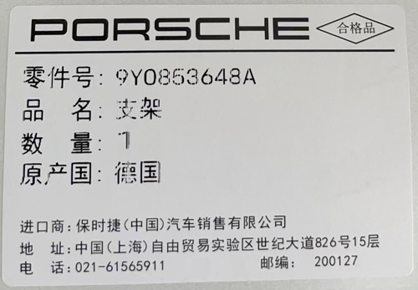

Automation & Digitalization Solution
The supplier is welcome to make proposal for automation and digitization solutions to gain lower human error, higher operation efficiency, maximized space utilization, enhanced working safety, and lower labor cost. The proposal should include layout, implementation plan, system implementation plan, ROI analysis, business analysis, similar experienced project, etc. However, only the proposal which the supplier confirm it will implemented to this project and quoted proposal in the <Appendix 9 Warehouse Quotation table> will be considered as valuable
As we developed Digital twin in our warehouses, the CCTV and other sensors should follow the requirements to meet the requirement of Digital twin, please refer to Appendix 8: CCTV and other sensor requirement
Automation technology includes but is not limited to:
- Goods-to-Person (GTP).
- Automated Storage and Retrieval Systems (AS/RS).
- Automatic Guided Vehicles (AGVs).
- Autonomous Mobile Robots (AMRs).
- Pick-to-Light and Put-to-Light Systems.
- Voice Picking and Tasking.
Automated Sortation Systems.

General Warehouse Processes

Inbound
Inbound Process- General Overview
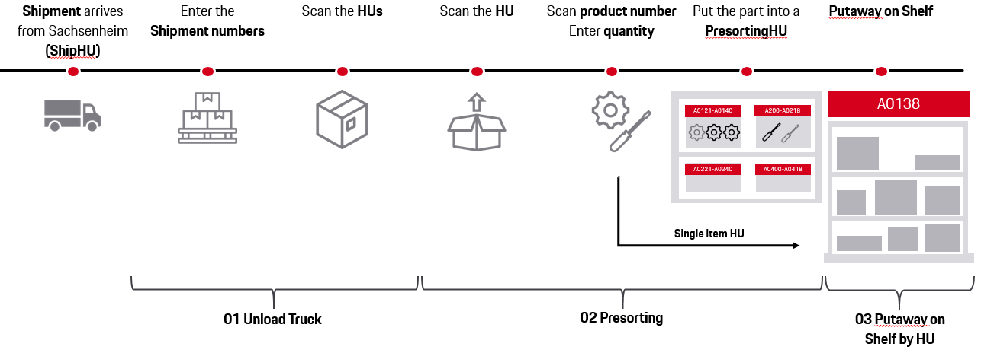
In the Inbound Shipment Process, the Warehouse (PDC) service provider is in charge for unloading the truck/container, make a quantity and quality check and put the material away on shelf, The service provider shall submit daily report for any exceptional case after quantity and quality checking with daily report template (Appendix 12 & Appendix 13).
As a support for quality checks, Porsche provides a system guided process (Appendix 11 Porsche EWM_ system and process Estimated key figures for calculating the tender are in Appendix 3 Warehouse operation data.
The specific process with operation requirement is defined in Appendix 4: Warehouse service of scope.

Storage
The rack system must contain sufficient bin location.

The classification of the part is defined about the largest dimension, as follow:
Large part: | at least one dimension larger than | 1300 mm (incl. packaging)
Medium part 2: | at least one dimension larger than | 600 mm (incl. packaging)
Medium part 1: | at least one dimension larger than | 250 mm (incl. packaging)
Small part: | all dimensions smaller than | 250 mm (incl. packaging)
High fluctuation in the SKU development is not expected. The number of required bin locations is essential and is the base for warehouse space (Storage space only, no functional areas).

Porsche Best Practice for Warehouse Equipment
The service provider will be responsible to provide sufficient MHE to fulfill daily operation(incl. all the services which has been described in the <Appendix 4_Warehouse scope of service>)volume within the target the time, also be responsible for the equipment maintenance. And please incorporate the relevant cost into operation cost.
PCN has 5 existing pallet mover(pls. see below list) in the past years, if the supplier would like to utilize them, the supplier shall be responsible for compliance requirements, as well as maintenance at its own cost,
The service provider shall be responsible for current racking maintenance, repair if damage, the new racks installation according to your proposal. And the one-time investment of new racks shall be charged to PCN according to the rack depreciation scheme (5 years).
Porsche China is expecting optimization for current storage in order to gain most utilization of space. The supplier shall make proposals and provide the quotation for the ideas. The optimization proposal is not limited to the racking renovation, but also current parts packaging could be considered

Racking
 |  |  | Bin Location Size (Inside Dimension) in mm
Category | Kind of Rack System | Proposal | Depth | Width | Height
Small parts | Box shelve system, Mezzanine | 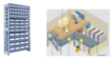 | 300 and 140 | 290 and 145 | 190
Medium parts I | Shelves, Mezzanine |  | 600 and 1,000 | 160,320,640 | 180,230,400,500
Medium parts II | Pallet rack system with inlays | 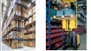 | 900 and 1200 | 800 and 1200 | 600 and 1,300  Ø 1060
Large parts |  | 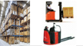 | 1,300 | 1900 | 1,300,1,800 and 2,000  Ø 1,700
Hoses on the wall |  | 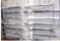 |  |  | max. 2,000

The table represents a proposal of storage systems used by Porsche with a clear height of 9m. The offer could contain other storing systems. The dimension of the bin locations is partly calculated. The height has to be adapted to the existing warehouse. For the offer an average height of the bin locations is defined.
The racking system requirements are defined in Appendix 5.

Small Parts: Boxes in a rack system. Each box should be easily reached by the picker. Several levels for picking (in a mezzanine) are possible. The best practice of Porsche is to consider the same shelves like for Medium part 1 (depth 600), but divide the depth of the boxes (cardboard boxes, plastic) with splitters. By using this system in the offer a certain amount of boxes should be considered.
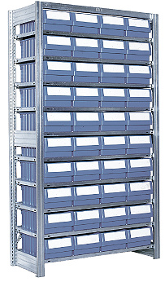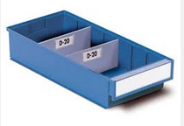
Medium Parts 1: Using a shelf with splitters. Each location should be easily reached by the picker. Several levels for picking are possible. No containers are required.
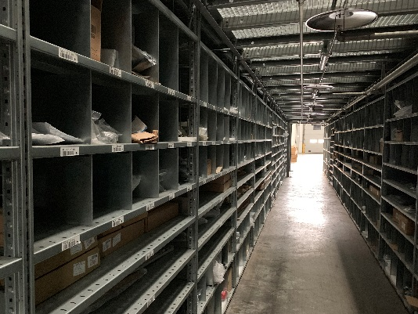

Medium Parts 2: Using a rack system (dimension of euro pallet, Rack brand: Schaefer or similar brand with high quality is recommended for rack purchasing). The first three levels are used for the fast-moving materials. The upper levels are used for slow-moving materials and should be served by a high picking machine. Best practice from Porsche is to consider mesh inlays in the racking system to be flexible, because the parts of Porsche are not palletized.
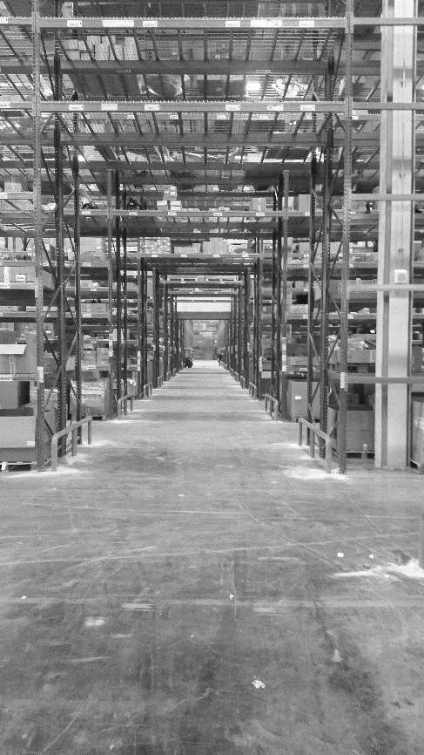

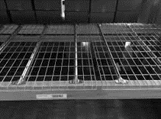

Large Parts: Using a rack system(Rack brand : Schaefer or similar brand with high quality is recommended for rack purchasing). The first two levels are used for picking. The upper levels are used for replenishment or for slow moving materials. The picking places are replenished by a forklift from the upper levels. Best practice: see medium part 2.

The locations are divided in picking locations and replenishment locations. The picking locations are usually used in the daily business meanwhile the replenishment locations are not used in daily business (contain slow moving or replenishment material).

Equipment
Based on the experience, the following material handling units are requested and should be considered in the offer. A special brand is not requested but the amount of machines shall be calculated by the logistic service provider.
All IT equipment (Access points, scanners, printers, computers …) are not content of the offer and shall be excluded.
The service provider shall consider the equipment requirement for Porsche future parts development (eg. E-vehicle parts : Li-battery, the equipment requires 1,6 t lift truck with fork lengthening to 2.0m and fork spread width more than 90cm)
Suggested MHE:
Order Picker | 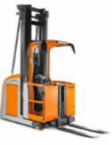
Manual Pallet Jack | 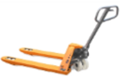
Manual Pallet Jack with scale  (at least one is mandatory) | 
Self-Propelled Electric Power Pallet Jack Truck (Batteries) | 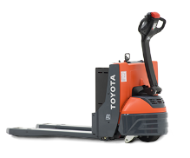
Reach Truck | 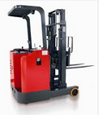
Picking Trolley | 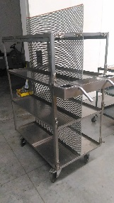
Forklift | 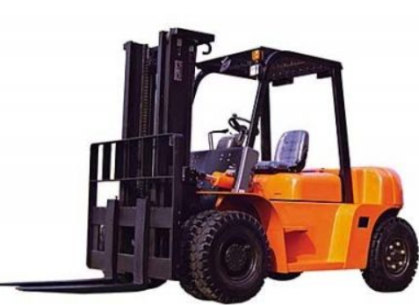
Pallet mover(5 existing) | 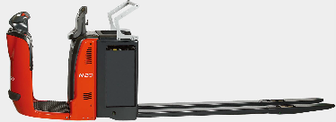

Outbound
Outbound Process- General Overview

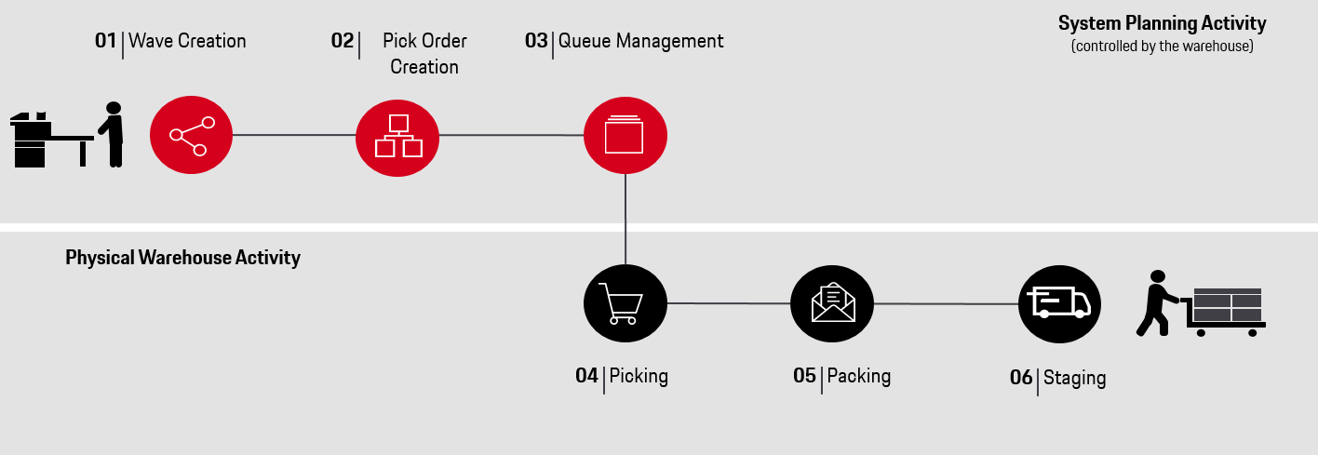

The scope of the Outbound process is to fulfill the orders out of the system by picking part by part and prepare the material for shipping. All procedures are guided by the Porsche own EWM system(Appendix 11 Porsche EWM_ system and process)
The number of order lines depends on customer orders and could have a high fluctuation (approximately +/- 30%) monthly and daily. Estimated key figures for calculating the offer are in Appendix 3: Warehouse operation data.
The specific process with operation requirement is defined in Appendix 4: Warehouse service of scope.
NOTE: Parts with expiring date need to be carefully checked. These parts can be displayed in the system.

The PDC Warehouse service provider is responsible for the supply of packaging material for transportation. Appendix 15: Consumption of package material represents the most used packaging. To reach the long term zero emission target, the service provider shall consider using sustainable packaging materials in daily warehouse operation. The sustainable packaging materials price would be included in the Appendix 9 Warehouse Quotation table (if any)

Special Processes

Scrapping Parts
In some cases, (returns, over stock, misdirected material) it is necessary to scrap the material. Only material approved by Porsche (China) Motors Ltd. can be scrapped by the logistics service provider. The logistics service provider generates a monthly report about material for disposal. Based on this report Porsche (China) Motors Ltd. evaluates which goods have to be scrapped and which goods can be reused.
The logistics service provider pick and pack the approved parts and handover to Porsche certified scrapping company. The documentation about the process, which based on the internal Porsche (China) Motors Ltd. scrapping guidelines, has to be done by the logistics service provider and submitted to Porsche (China) Motors Ltd. (Appendix 10: Scrap guideline).
However, in some cases (e.g., small parts and PDS parts) it is recommended to destroy the material directly in the warehouse, thus the PDC Warehouse service provider should have a possibility (workbench and equipment) for local simplified scrapping procedure.

Stock-Taking / Inventory Count
Full stock-take are required once a year (at end of December).
The PDC Warehouse service provider ensures a proper stock-taking process in compliance with Porsche guidelines, providing employees for physical counting as well as necessary equipment (e.g. fork-lift loader, stationery, etc.). Stock-taking has to be managed by Porsche (China) Motors Ltd. in accordance with internal corporative guidelines.
Normally the annual stock take should be finished within 2 days – 1 day to complete main count and 2nd day to finish the recount and final count, the service provider should take the increasing cost by its own, e.g. increased manpower, MHE, etc.
Cycle count should be conducted regularly, ensure all of the inventory will be counted twice a year.
In case of inventory shortage (unexplained difference in inventory between a physical count and the amount recorded) the losses shall be billed by Porsche (China) Motors Ltd. and are to be made up by the PDC Warehouse service provider according to dealer price.

Shelf life parts management
For shelf life parts, the service provider need to ensure recording the correct shelf life/expired date during the Inbound process; to check and correct the shelf life data on a regular basis, and to send shelf life parts report to PCN in a regular basis.
Stock movements should follow FIFO principle, taking account of cost effectiveness and traceability. The management of shelf life parts must follow the FEFO (First Expired, First Out) principle. Any loss resulting from violation of FIFO or FEFO principle shall be borne by the service provider.

Packaging Optimization
The service supplier is mandated to check the quality of the Inbound packaging and make suggestion(s) to optimize the packaging. The target is to create a proper packaging, which could be used from the global warehouse in Germany to the dealerships in China.
For the special part which has high damage risk, the service provider is mandated to do full inspection on part quality and packaging enhancement.
The service supplier is mandated to check and optimize the quality of the Outbound packaging, in order to secure smooth delivery as well as to avoid a risk of unforeseen transportation damages. Any damage which is caused by service provider’s improper operation or improper packaging will be reimbursed by service provider according to dealer price.

Hazardous chemicals and dangerous goods
The service supplier should obtain hazardous chemicals operating license if handling the hazardous chemicals and dangerous goods by itself, otherwise service provider should use qualified subcontractor to do the operation. The responsibilities of service provider include but not limited to the below scope.
- Ensure the inventory accuracy between system and psychical goods
- Ensure on-time process, including receiving and delivering
- The FIFO/FEFO standard is essential in the hazardous chemicals and dangerous goods management
- As the PCN’s own system is not available in DG warehouse, the service supplier or it’s subcontractor should provide their own system in DG warehouse to manage inventory including inbound/storage/outbound/ stock taking process
- The PCN or it authorized third party should have access to DG warehouse for inspection, auditing and taking picture at any time.

Local parts management
A small proportion of parts are locally purchased, which is also in the scope of warehouse management. It has different Inbound& Claim process from import parts. Please refer to Appendix 24 Local products order &Inbound& Claim process.

Operational System and Communication
As spare parts warehousing management system the Porsche system (Base: SAP) has to be used. The logistics service provider shall conduct all warehouse operations in the system provided and installed by Porsche (China) Motors Ltd.
Except for SAP system, PCN After Sales also using special Tracking& Tracing system(pTMS), the service provider should use this system in their daily operation (such as goods pick up, damage recording, unloading, quality check, Outbound handover, return and scrapping).
The service provider ensures a secure telephone and fax interface. Furthermore, the service provider support Porsche in technical feasibility for installing of Porsche networking equipment (e.g. trunking system). The service provider is expected to perform and document all warehouse activities according to Porsche’s processes and system guidelines.

Warehouse Key Performance Indicators
The KPIs must be reported by WHSE on a regular basis to Porsche as specified and agreed. (see Appendix 6 KPI &Bonus Malus and Appendix 7 Key Performance Indicators (KPI) Management Report (MR))

Human resource requirements

Organization
The contractor is required to establish complete and reasonable organization, qualified project manager and operation manager shall be nominated.
During contract phase, significant changes have been taken place within the company (such as renaming, major structural adjustment, financial problems, Key position personnel change, etc.), which bring important impact on the execution of contract, the contractor shall inform Porsche (China) Motors Ltd. 3 months earlier
The contractor should be the same as the one who attended the bidding and the operation team and manager in the proposal should remain the same in real operation and keep stable.

Recruitment
Recruitment, overtime, salary, welfare, and dismissal shall comply with the requirements of the labor law. Porsche (China) Motors Ltd. requires a dedicated warehouse operation manager for warehouse operation management and reserve the right to join in the interview and decision making of key position recruitment (e.g., warehouse operation manager).

Qualification & Authorization
- The qualification matrix for each position shall be clearly defined and followed during recruitment.
- Qualification review and training plan shall be set up
- Porsche (China) Motors Ltd. reserves the right to join the evaluation of key positions at the end of probation. If the qualification assessment is not qualified, the contractor is required to re-recruitment.
- Special positions and professional positions are required to have certification from local government.
- The key positions (including warehouse manager, supervisor, SAP specialist, Inbound team leader, outbound team leader, inventory management team leader, customer care) in warehouse operational team should be Full Time employees of service provider and dedicated to the Porsche warehouse.
- Warehouse operation manager should be authorized to approve at least RMB 50,000 for settlement of damage/shortage claim.

Miscellaneous

Warehouse Operating Hours
The general warehouse operating hours are Monday – Saturday, 08:30 am – 17:30 pm (including 1 hour lunch break time)

In exceptional situations over the weekend work may be required. Access to a qualified logistics service provider contact person (responsible for the warehouse) by phone, fax, and e-mail must be guaranteed between 6:00 a.m. and 10:00 p.m. All activities for Porsche (China) Motors Ltd. must be consolidated with a small number of contact persons. These dedicated employees have to be approved by Porsche (China) Motors Ltd. The contact persons for order processing at Porsche (China) Motors Ltd. shall be specified when an order is placed.

Emergency Concept
An elaborate emergency concept has to be prepared for the scope of warehousing (e.g., power blackout, strikes, etc.) and presented within the offer.

Reports
Porsche (China) Motors Ltd. expects a Monthly Management Report (MR) containing the key performance indicators about quantities, quality, and warehouse performance. The MR must be completed in accordance with Porsche (China) Motors Ltd. specifications and sent to Porsche (China) Motors Ltd. by the 3rd business day of the following month. The details are specified by Porsche (China) Motors Ltd. (Appendix 7: Key Performance Indicators (KPI), Management Report (MR)).

Environment and Sustainability
Porsche (China) Motors Ltd. is committed to protecting the environment. The contractors should strive to meet environmental and sustainability standards such as ISO 14001, or comparable management systems. Porsche (China) Motors Ltd. reserves the right to implement annual audits concerning the protection of the environment.
It is preferred that the service provider has the same carbon neutral target as PCN, implementing sustainability measures in daily warehousing operation to decrease CO₂ emissions and reach carbon neutral target by 2030.
Sustainability requirements are listed as follows.
- Warehouse should be operated in low-carbon emission ways (e.g., electric transportation tools, paper only used in necessity)
- Waste Management needs to be implemented (e.g., recycling process, reusable boxes, other initiatives to reduce waste)
- Show its CO₂ emission [tons)/p.a.], consumption of water [liter/p.a.] and electricity [Kwh/p.a.] on regular bases as well as its sustainability activities which are already implemented or planned for the future.
- Consider using sustainable packaging materials in warehouse operation.
- Define sustainability activities implemented or planned for the future, high willingness to cooperate the decarbonization initiatives operated by PCN (e.g. green supplier certification program, supplier project-based decarbonization)
- Prefer the service provider can demonstrate engagement with decarbonization frameworks such as Ecovadis, CDP, or SBTi.
- Fulfill further social (e.g. employee safety and health working conditions, diversity equity, etc.) and governance aspects (e.g. preventing bribery and corruption, taking care of cybersecurity and privacy practices).
- Fulfill social requirements: Building characteristics allowing discrimination-free working environment (e.g. separate sanitation rooms for male/female employees, barrier free access for employees with disabilities)

PCN will further define sustainability (CO₂ emissions reduction) KPI in Appendix 6 after warehouse operation official go live.

General Contract / Agreement Terms



Contractual Conditions

Contract Duration and Terms
- The warehousing contract (Inbound transportation & PDC operations) starts from Aug 2026. The agreement’s duration will be for 3+2 years (firm date to be determined later). Conditions should be fixed during the first contract period. An option of an extension is negotiable.
- The Inbound transportation service will start from Aug 2026 as well. Inbound transportation is included in the contract as optional service for PCN.
- The DG warehousing contract (Hazardous Chemical and Li-ion Battery), the agreement duration will be 3+2 years (firm dates to be determined at a later time). Conditions should be fixed during the first period. An option of an extension is negotiable. Porsche (China) Motors Ltd reserves the right to adjust contract period according to supply chain strategy change.

In case of infringing the contract especially by failing the defined targets (Appendix 6 & Appendix 7) and not reacting timely to two written appeals by Porsche (China) Motors Ltd., Porsche (China) Motors Ltd. is able to terminate the contract by one-month prior notice. In this case where the service provider is responsible for the termination, the service provider shall be liable for verified expenditure and costs due to the termination and change of service provider.

Insurance
The service provider is obliged to provide proof of appropriate liability insurance coverage commensurate with the content and risk of the agreement and its importance for the business. The service provider must take out a business liability insurance policy for bodily injury or property damage. The service provider must provide proof of this business liability insurance with adequate limit. Proof of coverage in all areas must be provided by the vendor to Porsche Cars China within the first thirty (30) days of agreement starting/effective date.
The relationship between insurer and insured may only be terminated or restricted in its scope with the consent of Porsche (China) Motors Ltd. Any measures and costs (e.g. security and fire protection measures) resulting from possible claims by insurance companies in relation to the organization of plant areas are the sole responsibility of the service provider.
Servicer provider is suggested to have below insurance:
- Public Liability Insurance: cover the liability risk of third parties’ bodily injury or property damage caused by Warehouse vendor within their operation premise and should make sure that the third parties’ property under their care, control or custody can be also covered.
- Cargo/Logistics Liability Insurance: cover the risk when warehouse vendor is responsible for the transportation. Especially for the transportation out of their operation premises.
- Employer’s Liability Insurance: cover the bodily injury of vendor’s own employees during operation.
- Property All Risk Insurance: if the vendor is not only the manager of the warehouse, but also the owner of the warehouse, they are also advised to purchase this insurance to cover the risk of their own property damage caused by natural disasters or accidents.
The service provider is requested to provide insurance details in the proposal.
Service provider should ensure the validity of all insurance mentioned above during the period of the contract and should notify PCN in written at least 30 days before the cancellation, expiration, and elimination of any of the insurance.

Liability
- Goods which are recognizably damaged may only be handled in consultation with Porsche (China) Motors Ltd. in the absence of general clearance for their onward transportation, separate clearance is to be obtained for each individual case of such damaged goods.
  - Cases of obvious damage recognized during the visual inspection in addition to direct damage, these also includes other defects, missing parts, and damaged packaging, are to be reported to the responsible personnel at the handover point without delay in order to obtain instructions, prior to taking receipt of the goods concerned.
  - Substantiated reservations of the logistics service provider with regard to the goods, their packaging, the number of packages, and their markings and numbers are to be acknowledged by the consignor.
  - In the absence of a substantiated reservation in the waybill or where a reservation has not been acknowledged by the consignor, it shall be irrefutably assumed that the goods and their packaging were in good condition as regards their external appearance at the time of handover, and that the number of packages and their markings and numbers correspond to the information provided in the waybill.
- Should the consignee establish any losses or damage on unloading of the goods, this is to be acknowledged by the logistics service provider or its subcontractors, where appropriate subject to clarification of the actual cause of the damage.
- Chinese law shall apply with regard to liability, including the limitation period for claims.
- The service provider should compensate Porsche (China) Motors Ltd. for any damage or loss to the consignment according to current-replacement-value.
- Within thirty (30) days of conclusion of the agreement, the logistics service provider shall be obliged to furnish confirmation that it possesses liability and property insurance coverage commensurate with the contents of this agreement and the risk entailed herein and shall be obliged to maintain the same extent of coverage beyond the term of the agreement for the period of one (1) year, in which claims for compensation or other claims are possible under the terms of this agreement or by law.
- Settlement of claims, Transport or Warehouse damage, must be dealt with directly between the Porsche (China) Motors Ltd. and the logistics service provider. The assignment of damage shall not be accepted. Cases of damage are to be reported promptly after being ascertained. The logistics service provider is to keep statistics of damage occurring in transit and is to furnish these statistics to Porsche (China) Motors Ltd. on a Monthly Management Report (MR) to Porsche on the 3rd business day of the following month. Subsequent notice of any concealed damage which has been caused by the logistics service provider may be given within the statutory time limits. The logistics service provider undertakes to ensure the swift settlement of claims.
- The responsibility of the logistics service provider under this agreement with respect to the goods to be accepted by the logistics service provider shall begin upon notification, and no later than upon acceptance by the Porsche dealer or Porsche (China) Motors Ltd.

Use of Subcontractors
Subject to prior approval from Porsche (China) Motors Ltd., the service provider shall be entitled to use subcontractors. Subcontractors shall be subject to the same requirements that apply to the service provider, including those set out in this tender. The service provider must inform subcontractors of their obligation to conform with the relevant regulations, in particular security regulations. For the approval the service provider provides all requested information about the subcontractor to Porsche (China) Motors Ltd. by itself, prior to the subcontractor(s) transporting any shipments. Failure to comply may result in the agreement being terminated immediately without any notice to the service provider.
Warehouse operations are not allowed to be subcontracted.

Responsibility/Warranty
The service provider shall be responsible for the subcontractor’s performance, the described services & functions and shall guarantee proper and contractually agreed performance to Porsche (China) Motors Ltd. The service provider must ensure that the staff required for the operation are qualified and capable of performing the task in hand. Furthermore, the service provider shall guarantee to maintain the performance level and the qualitative and quantitative inventory of the fleet and the equipment over the entire contract period.

Continuous Improvement Process
The service provider must actively look for optimization potential to increase productivity. Furthermore, the service provider must host continuous improvement workshops in their area of responsibility. Documentation relating to training measures and workshops must be submitted to Porsche (China) Motors Ltd. on request. Furthermore, the logistics service provider will be given a Porsche transportation and warehouse evaluation rating annually by Porsche (China) Motors Ltd. The continuous targets are as follows:
- increasing the productivity
- reducing costs
- maximizing quality and reliability
- on time delivery
Structured cost reduction potential must be demonstrated to Porsche (China) Motors Ltd.

Legislation/Guidelines
The content of these specifications shall form part of any future joint outline/transport agreements. The non-disclosure obligations must be complied with. The service provider shall be obliged to comply with all applicable regulations and guidelines as defined by legislation and Porsche (China) Motors Ltd.
The contractor (including subcontractors) should be qualified for handling DG and comply with statutory requirements. The relevant safety laws and regulations for DG warehouses & transportation are listed for reference:
- GB 15603-2022 危险化学品仓库储存通则；涉及危化品管理，全文参照
- 消防〔2023〕72号 租赁厂房和仓库消防安全管理办法（试行）
- 危险化学品安全管理条例；参照，危险化学品储存&运输企业相关规定
- 危险货物道路运输安全管理办法

The requested qualification list for DG warehouse & transportation is also listed in Appendix 19_危险货物运输及危险化学品存储企业资质合规要求. The contractor should provide complete requested doc in in the tender proposal.
The contractor is supposed to agree and strictly follow Porsche (China) Motors Ltd.’s work safety management agreement (Appendix 18) , also should elaborate your work safety management system and monitoring measures in daily PDC operation.

Governing Law, Jurisdiction and Place of Fulfilment
Future agreements shall be governed by and construed in accordance with the laws of China. The place of fulfilment and jurisdiction is China.
Any dispute, controversy or claim which may arise out of or in connection with these agreements, or the execution, breach, termination, or any other cancellation, as well invalidity thereof, which the Parties couldn’t settle during twenty (20) days from the moment of receipt by a corresponding Party of a claim shall be settled by Shanghai International Economic and Trade Arbitration Commission in accordance with its Rules. Place of hearing – Shanghai. The decision of the said court shall be final and may not be appealed.

Invoicing

General Terms
All price agreements shall apply as prices including relevant taxes. All services (intermediary transport and warehousing) are charged to Porsche (China) Motors Ltd. and to be billed in compliance with Chinese legal regulation using a template defined in advance with Porsche (China) Motors Ltd. Warehousing and transportation services are to be billed by logistics service provider on a monthly basis, within the last business day of the month, under stipulation that original documents shall be sent to Porsche (China) Motors Ltd. before the 8th business day of following month.
The basic prices within the scope of both the tender and future contracts to be agreed between Porsche (China) Motors Ltd. and the logistics service provider as fixed tariffs in RMB (incl. with possibility of re-consideration through an amendment to the contract if needed).
The invoices are to be billed and paid in RMB, in compliance with Chinese legal regulation, within certain period specified in future contracts.
The agreed prices shall satisfy all the claims accruing to the logistics service provider. Offered and agreed prices must remain valid in the event of divergent volumes.
The service provider shall not be permitted to charge additional costs or costs other than those agreed by contract without prior agreement. In case of additional expenses (transport-related additional costs, overtime work etc.), they must be agreed separately with Porsche (China) Motors Ltd. in advance and shall generally be invoiced to Porsche (China) Motors Ltd. after they have been paid by the service provider. Invoices are to be structured according to a model which is to be agreed with Porsche (China) Motors Ltd.
The central invoicing address for all Porsche (China) Motors Ltd. operations is:
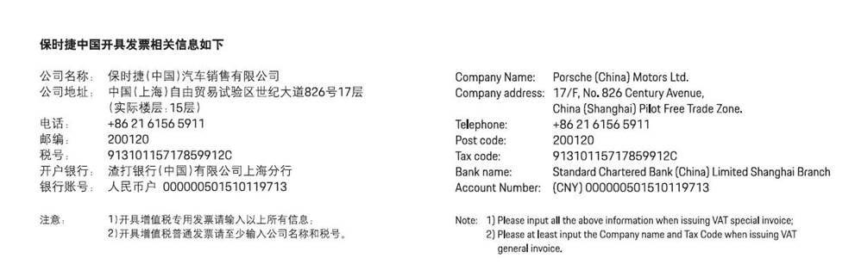

The following points are to be observed with regard to invoices:
- The services rendered are to be itemized in detail and in a comprehensible manner.
- The order number or cost center and Porsche (China) Motors Ltd. ordering party/department must be indicated.

Content of the offer
By submitting the bid, the bidder should sign off the <Appendix 25 Commitment letter for proposal> with company chop as precondition, otherwise, the proposal will be regarded as invalid. And,
The offer should include at least below content:
- Information about the company (especially partnerships, joint ventures…)
- Profit-and-loss report and balance sheet for 2025 year (with the mark of acceptance by tax authority or final audited results)
- References for other OEM in the Chinese market
- Detailed information about the warehousing concept. Thereof a description of the offered building and a layout of the racking are essential.
- Org-chart
- Project Timeline
- References for EWM system operation experience (if any)
- Provide a list of all current subcontractors with their work scope and their weight in business.
- Complete pricing table for warehousing, &Inbound transportation (see Appendix 9)
- Proposal for automation and digitalization solution, or other ideas that integrating with Digital Twin, ONLY which could be implemented to current operations, and need to attach timeline, ROI analysis, and quotation
- Proposal for green inbound transportation
- Sustainability roadmap, target and tracking reports
- Proposal for sustainable measures / ideas ONLY which could be implemented to current operations, and need to attach timeline, ROI analysis, and quotation
- DG warehouse & transportation qualification (危险货物运输及危险化学品存储企业资质合规要求)
- Work safety management system and monitoring measures.
- Insurance

Porsche (China) Motors Ltd. requests a authorized warehouse operation manager planned for this PDC and warehouse landlord to join in the proposal presentation. PCN requires service provider to appoint a dedicated warehouse operation manager planned for the contracted service duration to participate in the entire tendering process and presentation If the service provider cannot appoint an exclusive warehouse operation manager with his/her profile, or no required experience of after parts operation, or no authority of RMB 50,000 budget for settlement of damage claim, the proposal will be judged as invalid and the service provider will be judged as quit of bidding.

Guarantee requirement
Considering that the registered capital of some winning bidder company may be lower than the value of the stored goods they handle, to ensure the winning bidder can properly fulfill their contractual obligations, in such cases, the winning bidder needs to provide a guarantee from their parent company or affiliated company. The guarantee template is as attached <Appendix 27 SP Parent Company Guarantee for the Warehousing Agreement>

Appendixes Listing
Appendix 1_Dealer list
Appendix 2_Inbound volume
Appendix 3_Warehouse operation data
Appendix 4_Warehouse scope of service
Appendix 5 _ Rack system Requirements
Appendix 6_KPI & Bonus Malus
Appendix 7_Key Performance Indicators (KPI) Management Report (MR)
Appendix 8 CCTV and other sensor requirement
Appendix 9 Warehouse Quotation table
Appendix 10_Scrapping guideline
Appendix 11_Porsche EWM_system and process
Appendix 12_1_Daily report template_Outbound
Appendix 12_2_Daily report template_Inbound
Appendix 12_3_Daily report template_Part discrepancy
Appendix 13_ Damage report
Appendix 14_DG list
Appendix 15_HV Battery Information and Forklift Operation Request
Appendix 16_Emergency Issue Process
Appendix 17_AEO Request from PCN
Appendix 18_Work Safety Management Agreement
Appendix 19_危险货物运输及危险化学品存储企业资质合规要求
Appendix 20_Floor Coating requirements
Appendix 21 _Information Security Terms and Conditions
Appendix 22_Warehouse operational service contract_template
Appendix 23_Shanghai warehouse layout
Appendix 24 Local products order &Inbound& Claim process
Appendix 25 Commitment letter for proposal
Appendix 26 Commitment of not Violating Laws Regulations and Trade Security

